[](http://www.broadbandgenie.co.uk/images/fckImages/logos/daily_telegraph_logo.gif)

**True dramas of the world’s bravest actors**

**Dominic Cavendish talks to the Belarus Free Theatre about death threats at home and the significance of staging 'King Lear’ here.**

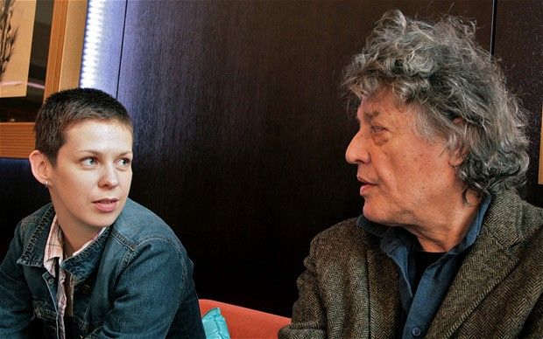

Natalia Koliada, co-founder of the Belarus Free Theatre with Sir Tom Stoppard

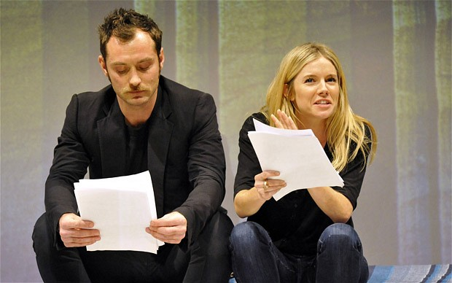

Image 1 of 2

Belarus Free Theatre supporters include Jude Law and Sienna Miller Photo: KEITH PATTISON

[http://i.telegraph.co.uk/multimedia/archive/01772/Cavendish_60_1772017j.jpg](http://www.telegraph.co.uk/culture/culturecritics/dominiccavendish/)

By [Dominic Cavendish](http://www.telegraph.co.uk/culture/culturecritics/dominiccavendish/)

6:24PM BST 04 Apr 2012

If you need to take anyone’s word about the Belarus Free Theatre, then let it be that of Sir Tom Stoppard. Critics can proclaim until they are blue in the face about the company’s significance, its fearlessness in the face of brutal repression and the prolific and daring nature of its artistry, but the most persuasive advocacy comes from Britain’s most distinguished living playwright.

Stoppard is one of a number of luminaries – others are Jude Law, Sienna Miller and Sam West – to be public in his support for a troupe effectively banned by the dictatorial regime of Alexander Lukashenko, and which now operates on a tense, ad-hoc basis, underground in Belarus, in exile in London and wherever else it is invited.

His Czech origins and championing of eastern European dissidents under Communism, though, lend particular weight to his comments about the company’s remarkable fortitude.

“I’ve known them for about six years,” he says. “I met them in Minsk. Then they were an outlawed theatre group who performed rather in the way that artists had to perform in Communist times – where one would get word out in a roundabout way as to where the venue would be and got hassled by the police; all that was going on.

“Those were innocent days compared with the situation now. Then, there was a price to pay – they might get beaten up or arrested – now they could end up in jail for years… or worse.

“They seem to defy gravity,” he continues. “Almost anyone else would say, 'We’d better disband and try to find some life outside of this’, but they’re dedicated to their existence as a theatre company, performing in Belarusian. I have seen the effect they have on audiences in places as far apart as Paris, New York and Leeds.

“Their impulse is to be as interesting as possible artistically. They’re absolutely inspiring.”

Those who have not yet clapped eyes on the company – hailed as the bravest in the world – have their chance twice this spring. There’s a new tour of Minsk 2011: A Reply to Kathy Acker – a savagely entertaining look at sexuality, and its repression, in Belarus. But of far greater import is the Free Theatre’s debut at Shakespeare’s Globe with King Lear next month as part of the 2012 Globe to Globe season.

The director of the festival, Tom Bird, who has seen rehearsals, explains: “Their version – unsurprisingly – is a contemporary account of the play. It’s very stripped back, so people shouldn’t expect doublet and hose.”

Bird says that the play, directed by Vladimir Shcherban and starring 52-year-old Oleg Sidorchik as Lear, is “informed by first-hand experience of tyranny and the arbitrary use of power”.

The suggestion of Lear, with its hurtling descent into civic and mental collapse, was the Globe’s, but the company leapt at the opportunity. It marks the first time since its inception in 2005 that it has taken on a classic. Having given performances in converted apartments and houses in their home country, the prestige of the venue means a great deal to these actors: “To be a banned company from the last dictatorship in Europe doing Shakespeare in the heart of London right before the Olympics sends out a strong message,” says Natalia Koliada, co-founder of the company with her playwright husband Nikolai Khalezin.

But with the Belarus Free Theatre, art – not activism – is paramount. Crude parallels with Lukashenko won’t be drawn. “We will be stooping to a very low level if we make it just about him,” Koliada affirms, with a grim smile. “The issue is much broader. There are parallels, too, with Syria and what’s happening in the Arab world. Lear is a man who, like Gaddafi, can’t quite let go of power.”

Koliada and her husband’s combined experience of arrest, detainment and abuse at the hands of the authorities at different times would run to many harrowing pages of testimony. Neither is safe to return home – “We receive death threats even in London and Washington,” she alleges – and those they consort with in Belarus, whether it be actors (continuing to train and perform in clandestine circumstances) or close relatives, face all kinds of harassment and potential punishment; this can range from loss of work and housing to incarceration.

“It’s interesting, what we’re living through really reflects the situation of King Lear,” Koliada says. “Many of us are homeless – it was necessary to give up everything to do what we do.”

In London, Koliada and the actors who have joined her and her husband by surreptitious means for this project bed down where they can, moving from place to place. Yet Koliada is adamant: “We have said that even if we end up living under a bridge, we will come on stage and perform. We have to do this.”

***'King Lear’ is at Shakespeare’s Globe May 17-18; 'Minsk 2011’ tours to Leeds, Bristol and is then at the Young Vic, London (020 7922 2922 begin_of_the_skype_highlighting 020 7922 2922 end_of_the_skype_highlighting), June 15-23. Donate at*** [***belarusfreetheatre.com***](http://www.belarusfreetheatre.com)