

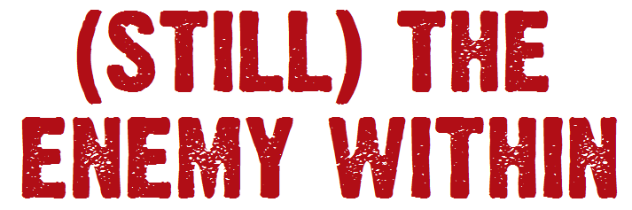

**A Feature Length Documentary**

In 1984, Margaret Thatcher labelled 160,000 striking miners, their families and supporters, ‘The Enemy Within’. It was to be the longest national industrial dispute in British history.

As the strike began, a group of miners emerged who were prepared to fight on the front line of every major battle. They were treated with suspicion by some in their own union, demonised by the media and despised by the government.

Dubbed ‘Arthur’s Army’, they were to lead a fight-back that would not just rock the government but would change British society forever…

**(Still) The Enemy Within** that uncovers the hidden story of these remarkable people and their role in The Great Miners Strike of 1984 – 85.

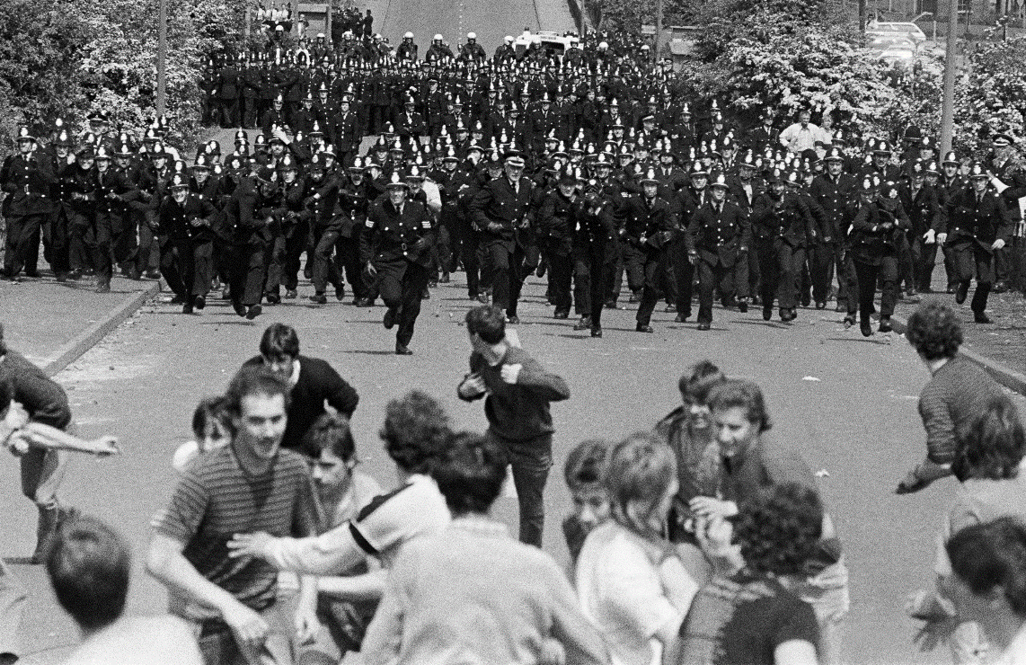Thirty years on, we catch up with Norman Strike, Jim, Howard, Buck, Jip, Joe and Steve to find out what life was really like on the front line. Whether it’s the comic misadventures of having the surname ‘Strike’ or running battles with the police and the death of a best friend, their stories are at once funny, dramatic, sad and ultimately inspiring.

Through their eyes, we look back at a country at war, and the ordinary men and women who were forced to step on to the stage of history to fight for their communities.

Often, the story of the Miners Strike is told simply as the story of Thatcher vs Scargill. Here we’ll meet the real leaders on the ground who spent every day for a year, fighting not just for their jobs but for the soul of the country. They faced betrayal by trade union leaders who left them increasingly isolated but also solidarity from ordinary people who courageously fought alongside them. Their story is not one of inevitable defeat but of missed opportunities and what could have been.

In this feature-length documentary, their incredible story will be told using:

* **Interviews** shot in astonishing derelict locations – a reminder of Britain’s industrial past and the scars left behind by the Miners’ defeat. We also meet the supporters whose bravery and solidarity helped keep the strike going and who in turn were transformed by the experience.
* **Animations** incorporating archive and illustrations to bring the history to life.
* **Archive**, with a wealth of historical material from the time, including rare stills and footage.
* **Recon** - using stylish black and white abstracts to help recreate their personal stories



* **Actuality** – taking our miners back to some of the key events of their past and following them as they prepare to confront their old enemies and protest at the Tory party conference.

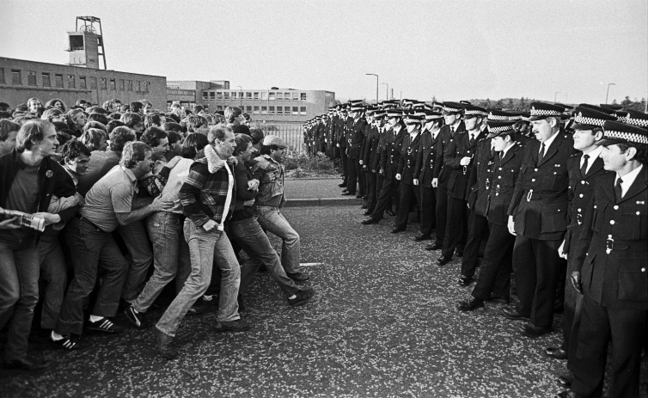**(Still) The Enemy Within** will be a truly unique insight into one of Britain’s most dramatic struggles, told by those who fought on the frontline. With the **30th anniversary** approaching, there has never been a better time to tell their story.

This film is being made by **Bad Bonobo**, bringing producers Mark Lacey and Sinead Kirwan together with director Owen Gower on their first feature documentary. They are collaborating with Mike Simons, the author of two acclaimed books on the strike: ‘Blood, Sweat & Tears: Photographs from The Great Miners Strike’ and ‘Striking Back. The project is also being made in collaboration with photographer John Sturrock who took the most iconic images of the strike. John is donating all his images free of charge.

The film builds on the 30 year relationship Mike and Sinead have had with the miners and their families. This has allowed us access to people who have never been willing to talk about their experiences on camera before. The key interviews will be shot by the end of September 2013 and the edit is underway. The aim is to release the film in 2014 to coincide with the 30th anniversary of the strike.